************GIT -02 ***********

- Install git.

- Create a repo in github with README.md and .ignore file.
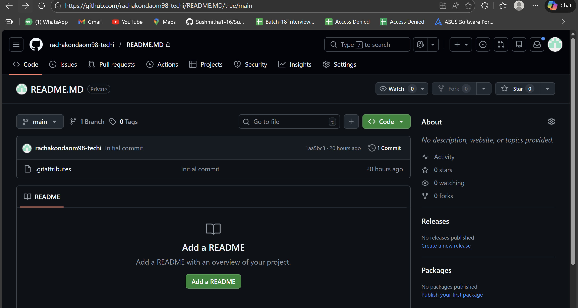
- Clone the created repo to local.
- Create two files in local repo.
- Commit two files and push to central Repository.
- Create a branch in local and create a sample file and push to central.
- Create a branch in github and clone that to local.
- Merge the created branch with master in git local.
- Merge the created branch with master in github by sending a pull request.
- Create a file in local and send that to branch in github.
- Clone only a branch from github to local.
- Create a file with all passwords and make that untrackable with git.
- Make a commit and make that commit reset without savings changes.
- Revert a commited commit to the older version.
- Push a file to stash without savings the changes and work on another file.
- Undo the stash file and start working on that again.
- Generate a ssh-keygen and configure into github.
- Configure webhooks to github.
- Basic understanding of .git file.
- Check all the logs of git.
- Rename the commit message.
- Merge multiple commits into single commit.

